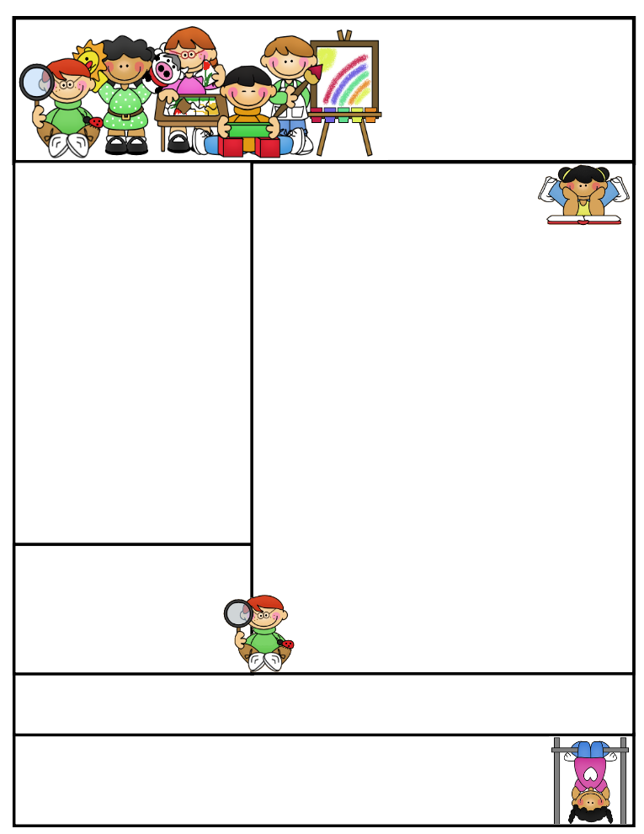

Birthdays

-Jan. 18 Isaac Newren

-Jan. 22 Breylon Larsen

Tip of the Month

Homework Helps

-Be available to encourage, praise, advise, and supervise

-Monitor your child’s understanding of concepts and skills

-Provide related home-learning experiences to reinforce concepts learned at school

-Cooperate and be supportive of the child’s teacher

-Don’t allow the child to skip an assignment he/she doesn’t like

-Don’t fill the child’s life with so many non-school activities that there is no time left for homework.

Created by Ashley Magee Graphics © ThistleGirlDesigns.com

Miss Millett’s  
Newsletter

January 7, 2013

Miss Jenessa Millett Email Address: jmillett@alpinedistrict.org  
Saratoga Shores Elementary   
Phone: (801) 766-6440 ext. 126

Homework

Homework folders will be sent home tomorrow. They will help you get a better picture of what we are learning in class.

These folders must be turned in by the **last day of the month** for your child to receive a treat. All of the papers you will need to complete the homework are provided in the folder. With the sight word posters, have your child read them while pointing to the first letter of each word as they read. Feel free to contact me with any questions.

In addition to the homework provided in the folder, please make sure your child reads for at least 15 minutes a night and is also practicing writing the letters we have learned in class. Any reading counts whether you read to them or they read with you.

We are going to start giving spelling tests on our sight words. A sheet will be sent home with the words and the date of the test. Please work with your child on the words so they can do well. Thanks!

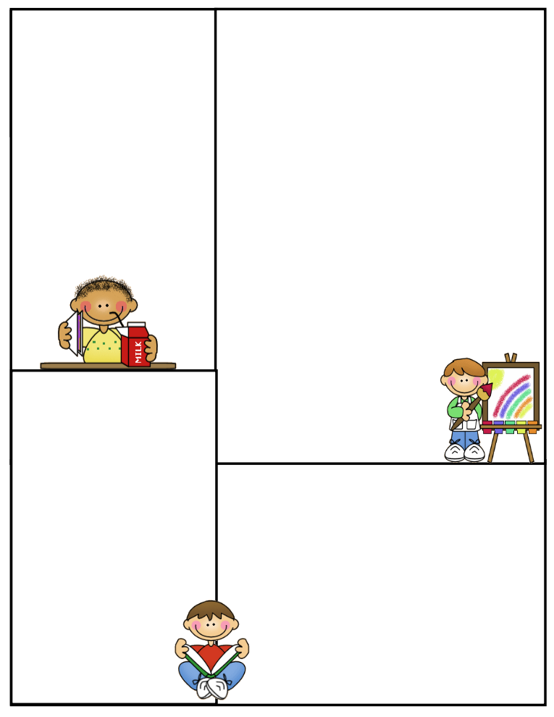

What We’re Learning This Month

Phonics: vowels: u Word Families: -at, -et, -ing

Sight Words: up, went, on, my, me, play, come, he

Math: measuring, comparing numbers

Reading: informational text

Writing:two part stories

Spelling Test Dates and Words:

-Jan 10th: the, can, is, it, go

-Jan 17th: boy, girl, in, at, am

-Jan 24th: look, to, like, said, do

-Jan 31st: you, and, we, big, this

Other Information

Raz Kids: Please continue to have your child use Raz kids. It is a very valuable program and will greatly improve their reading skills.

Take Home Library: Our take home library is up and running! Please notify me if you need a change in level for your child’s books.

Volunteers If you have agreed to be a volunteer for our class, please let Miss Millett know if you will not be able to make it on your day to help ahead of time. Also, please look at the schedule to know when you are to come or ask Miss Millett or a room parent.

My Website: www.millettkinder.weebly.com

Contacting the Teacher

As a teacher I highly value maintaining positive relationships and partnerships with the parents of the students in my class. Please do not hesitate to come to me with any concerns or questions you have about your student or anything going on in class. The best way to contact me is via email. However you may call or come see me after school between 3:30 and 4:00. I If you need to meet with me in person, I would appreciate if you would set up an appointment in advance. This way I make sure I have my preparations finished before we meet.

Room Parents

We had a wonderful Christmas Party before the break! Thank you to everyone who helped out or contributed in any way.

Please watch for emails and messages from our two room moms so you can get information about volunteering.